**SOFTWARE ENGINEERING LABORATORY**

**(UCS06P32)**

*A Sessional Report Submitted to*

# NATIONAL INSTITUTE OF TECHNOLOGY, AGARTALA Bachelor of Technology Department of Computer Science & Engineering SAVITALA V S N SAI SRIDHAR 20UCS065 6th SEMESTER Section - A (Group 2)

*for the Partial fulfilment of the degree of*

*in*

*By*

**LIBRARY MANAGEMENT SYSTEM**

*Under the Supervision of*

# Dr. Awnish Kumar

*Assistant Professor, CSE Department, NIT Agartala*

*AND*

# Mrs. Mandira Bhowmik

*Technical Assistant, CSE Department, NIT Agartala*



COMPUTER SCIENCE & ENGINEERING DEPARTMENT

NATIONAL INSTITUTE OF TECHNOLOGY, AGARTALA

# DECLARATION

I hereby declare that this report entitled "Digi Library : Library Management System" represent my ideas in my own words and where others' ideas or words have been included. I also declare that I have adhered to all principles of academic honesty and integrity and have not misinterpreted or fabricated or falsified any data/idea/fact in my submission. The report has not been submitted, in whole or in part, for any other degree or qualification at this or any other university.

SAVITALA V S N SAI SRIDHAR

20UCS065

Date :

# ACKNOWLEDGEMENT

I would like to express my gratitude to all those who have contributed to the completion of this project. First and foremost, I would like to thank my supervisor Mrs.Mandira Bhowmik, for her guidance, support and encouragement throughout the project.

I would also like to extend my sincere thanks to my team members for providing me with the resources and necessary facilities for the successful completion of this project.

I would also like to thanks my friends and colleagues for their support, feedback and encouragement throughout this project.

SAVITALA V S N SAI SRIDHAR

20UCS065 Date :

***INDEX***

|  |  |  |
| --- | --- | --- |
|  | Name Of Experiment | Remarks and Signature |
| 1 | Problem Statement for Library management System |  |
| 2. | SRS Document for Library management System |  |
| 3 | Level-0 DFD and Level-1 DFD for Library Management System |  |
| 4. | Use Case Diagram for Library Management System |  |
| 5 | Activity Diagram for Library Management System. |  |
| 6. | Sequence Diagram for Library Management System. |  |
| 7 | Collaboration Diagram for Library Management System |  |

**Assignment No.1** : Problem Statement for Library Management System

## ***1. PROBLEM DEFINITION***

The library management system is a software which acts as a platform that maintain library records. It tracks the records of the number of books in the library, how many books are issued, or how many books have been returned or renewed or late fine charges, etc.

1.1) The purpose of this software is to develop a Library Management System.

1.2) If the user is new, he/she can register to become the member of library.

1.3) The user can borrow on interested books after logging in with verified username and passwords credentials. The software confirms user authenticity and provides information on borrowed books and all details of that users including fines, date of issue of books, date of submission of books, offer if there is any and many more.

1.4) The user can similarly request for new books by providing relevant information on the books he/she wishes to have.

**Assignment No.2** : SRS Document for Library Management System

***2. SYSTEM REQUIREMENT SPECIFICATION (SRS)***

## 2.1) INTRODUCTION

2.1.1) Purpose :

1. The purpose of this SRS is to describe their requirements involved in

developing a library management system.

1. The intended audience are any person who wish to borrow books, library staffs inserting and managing data of all the members and the admin who will take decision on the format and structure of database of all the books, staffs and members in library.

2.1.2 Scope :

i) The product is titled Library management system. ii) The software will execute the following tasks :

* Let library staffs to manage the details and records of all the books and library members.
* Let interested borrowers borrow books from library.
* Let the borrowers provide feedback and rate library.

2.1.3 Definitions, Acronyms and Abbreviations :

1. Library management: A library management system is software that is

designed to manage all the functions of a library. It helps librarian to maintain the database of new books and the books that are borrowed by members along with their due dates. This system completely automates all your library's activities. The best way to maintain, organize, and handle countless books systematically is to implement a library management system software.

1. Online classifieds: Online classifieds are a form a advertising which are sold

or distributed free of charge with the intention of promote a sale or requirement.

1. DBMS : Database Management System iv) HTTP(s) : Hyper Text Transfer Protocol(Secure)

2.1.4 References :

IEEE standard 30-1998 recommended practice for Software requirements specifications description.

2.1.5 Overview :

1. The SRS contains an analysis of the requirement necessary to help easy design
2. The overall description provides interface requirements for the library

management product perspective hardware interface, software interfaces, communication interfaces, memory constants product functions, user characteries and other constraints iii) Succeeding pages illustrate the characteristics of typical naive user accessing the system along with legal and functional constraints enforced that affect Library management system in any fashion.

2.2) OVERALL DESCRIPTION :

### 2.2.1) Product Perspective

#### 2.2.1.1) Hardware Interface

* Server-The System requires a centralized server to host the software as users will all need to access the same information. This makes it necessary to employ server capable of handling high traffic which may occur during actions.
* Net Connection - The Server and client both require to be connected to the internet to enable communication between user and server
* The system must interface with the standard output and input devices like keyboard to interact with website through browsers.

#### 2.2.1.2) Software Interface

i) Backend: Python, Django ii) Data Base: SQL iii) Frontend: HTML, CSS, Jquery, Ajax

2.2.1.3) Memory Constraints

No Specific constraints on memory

#### 2.2.1.4) Operations

The Software allows three modes of operations

* Allow a librarian to add, remove and verify students and issue and refund the books
* Allows a student to take book and return book and raise issues.
* Allows a librarian to add new books and delete outdated books

### 2.2.2) Product Function

* Searches the library database to find an existing or new user
* Searches the library database to find an existing or new book

*Allow students to borrow and return books

* Allows librarians to add new students or delete ones

### 2.2.3) User Characteristics

2.2.3.1) The intended users of this software need not to have any specific knowledge as to what is the internal operations of the system. They must simply be familiar with the concept of online library systems. The end user is at high level of abstraction that allows easier, faster operation and reduces the knowledge requirements of the end user.

2.2.3.2) The product is meant to be highly user friendly and the intended users can be considered naïve.

2.2.3.3) Knowledge on simple computer usage and connection to the internet is sufficient to access and operate the software.

## 2.3) SPECIFIC REQUIREMENT

### 2.3.1) Functional Requirements

* Login:

Description: Staff member will login to the system. The user must be registered in the system before login.

Input: Enter the username and password.

Output: Staff will be able to use the features of software.

Processing: Username and password will be checked by the system. If they are incorrect a message will be displayed.

* Add/Remove books:

Description: The staff can add or remove book by entering details.

Input: Enter the book detail you want to remove or add within the stock.

Output: Confirmation of addition or deletion and update list of books available. Processing: The details of books must be right in order to add them else there will be problems in future.

* Search:

Description: The users can search a book by entering book details such as author’s name, book name etc.

Input: Enter the details you know about the book.

Output: The list of available books is displayed.

Processing: A message is displayed if the book related to the entered details is not available.

* Issues book:

Description: The staff member checks the availability of book which the member want to get issued.

Input: Enter book code.

Output: Confirmation for book issue or apology for failure in issue. Processing: If selected book is available then the book will be issued and the record is updated else error will be displayed.

* Return book:

Description: The member wants to return the book.

Input: return the book to the library.

Output: The record will be updated.

Processing: If book is not returned on the time then fine is calculated .

* Fine:

Description: If book is not returned on the time by member then fine is charged on per day basis.

Input: check for the fines.

Output: Details about fines on the book issued by the staff.

Processing: The fine will be calculated, if it crossed the date of return.

### 2.3.2) Performance requirements

There are no particular extra performance requirements at this point of time. 2.3.3) Logical Database Requirements

Proposed database is intended to store, retrieve, update and manipulate information related to college which include:

* Books availability
* Staff information
* Member details
* Calculation of fines

## 2.4) FRONTEND DESCRIPTION

The library management system is an application based platform for user to use the book from a store or library. The software itself is an app based conventional app operates such as authentication trough username and password and search the book for the user is looking the UI/UX responses accordingly. If there is availability for such any queries the response will work on it. This is an arbitrary classification can use the different user.

## 2.5) BACK -END DESCRIPTION

The library system is a software platform which responses the given user using the backend one consists all relevant information book database and all information for user status. which store the history of books and current librarians’ data.

**Assignment No.3** : Level-0 DFD and Level-1 DFD for Library Management System

DFD stands for DATA FLOW DIAGRAM

***Level-0 DFD :***

Book request

Library card

Requested

book

Book

LIBRARY

MANAGEMENT

SYSTEM

STUDENT

BOOKS

***Level-1 DFD :***

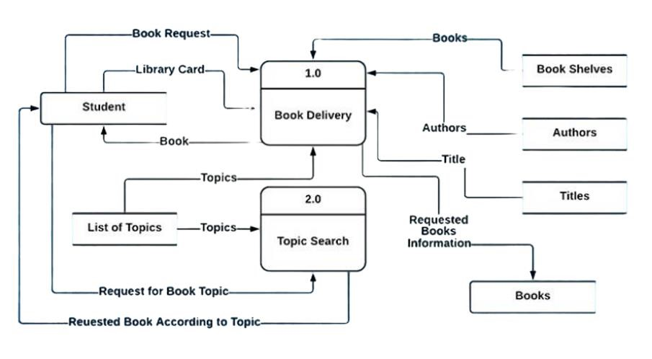

**Assignment No.4** : Use Case Diagram for Library Management System

LIBRARY STAFF

MEMBER

LOGIN

ISSUE

BOOK

ADD/DELETE

MEMBER

RETURN

BOOK

ENQUIRY/SEARCH

A BOOK

ADD/DELETE

BOOK

MAINTAIN

MEMBER

RECORD

MAINTAIN

MEMBER

RECORD

***Use Case description***  **LOGIN :**

1. **Brief Description:**

This use case describes how an actor login into the ‘Library Management System’.

1. **Actors:**

Library Staff **3. Flow of events:**

1. Basic Flow:

This use case starts when the actor wishes to log into the ‘Library Management System’.

The system requests the actor to enter the username and password.

The actor enters his/her username and password.

The system validates the username and password and then the actor is logged into the system.

1. Alternative flows:

If in the basic flow, the actor enters an invalid name or password, the system displays an error message. The actor can use to either return to the beginning of the basic flow or cancel the login at the point where use case ends.

1. **Pre-conditions:**

The actor must have an account created in the system prior to executing the use cases.

1. **Post conditions:**

If the use case was successful, the actor is logged in to the system. If not, the system state is unchanged.

**ADD/DELETE MEMBER :**

1. **Brief Description:**

This use case describes how an actor adds or deletes the user’s record in the system.

1. **Actors:**

Library Staff **3. Flow of events:**

**a.** Basic Flow:

This use case starts when the actor has to add or delete users/members within the ‘Library Management System’.

The actor fills the details of the member.

The member is then added to the system now the member got registered for further uses.

The actor can delete a member by filling the appropriate details. **b.** Alternative flows:

If in the basic flow the actor fills wrong details while deleting a member then the system displays an error message. The actor can either return to the beginning of the basic flow or can cancel the deletion of the member from the system.

1. **Pre-conditions:**

The member must added into the system before the actor deletes him/her.

1. **Post conditions:**

Record for a member has been added.

**ISSUE BOOK :**

1. **Brief Description:**

This use case describes how the staff issues book when requested by the member.

1. **Actors:**

Library Staff

Members

1. **Flow of events:**

**a.** Basic Flow:

If a member wants to borrow a book it is important that the staff should login to the system.

If login is successful the staff should enter the member id to be searched.

If the member search is successful the staff should enter the book id.

If the book is available then it can be borrowed. **b.** Alternative flows:

If the login fails then the staff should re- register themselves.

If the member search is unsuccessful then the staff should re-register the student.

If the book search is unsuccessful and book data is not found then the staff must enter the book in requisition report.

1. **Pre-conditions:**

To borrow any books it is important that the member is registered and the book to be borrowed is available.

1. **Post conditions:**

Book is reserved for the member.

**RETURN BOOK :**

1. **Brief Description:**

This use case describes how the return book procedure carried out when requested by the member.

1. **Actors:**

Library Staff

Members

1. **Flow of events:**

**a.** Basic Flow:

Member gives the book to be returned to the staff member.

Staff member checks if the book is returned on time.

Staff member update the book records. **b.** Alternative flows:

In the basic flow the staff member checks if the book is returned on time if it is not on the time then he/she generates slip of calculated fine.

The member submits the fine.

1. **Pre-conditions:**

Book/s must have been issued to the member.

1. **Post conditions:**

Report on fine is updated.

**MAINTAIN MEMBER RECORD :**

1. **Brief Description:**

This use case describes how the actor maintains the record of members which includes edit or view the member’s data.

1. **Actors:**

Library Staff **3. Flow of events:**

**a.** Basic Flow:

Staff member login to the system and selects the menu option to change the data of specific member.

Enter the name of categories that he/she want to change.

The system save the change in membership record and update previous record.

To view the record of a member the actor selects from the menu option.

LMS presents the record of members. **b.** Alternative Flows

If the password is incorrect then a message is printed on the screen and staff member is returned to the beginning.

If the name of changed to be category is not among the existing categories a message is printed on the screen and the actor is returned to the menu screen.

1. **Pre-conditions:**

Password or username must have registered.

1. **Post conditions:**

Member record is updated in database.

**SEARCH A BOOK :**

1. **Brief Description:**

This use case describes how the actor can search for a particular book.

1. **Actors:**

Member

Library staff

1. **Flow of events:**

**a.** Basic Flow:

Member or staff enters the book name or ISBN or author name and presses search

If the search is successful then that book is displayed on the screen.

1. **Pre-conditions:**

The book to be searched should be registered into the database of the ‘Library Management System’.

1. **Post conditions:**

List of books according to search data is appeared on the screen.

**ADD/DELETE BOOK :**

1. **Brief Description:**

This use case describes how the actor adds or removes the books.

1. **Actors:**

Library staff

1. **Flow of events:**

**a.** Basic flow:

The staff login to the system.

If login is successful then to add a book the staff must search for the book.

If the book is not found then it is checked in the requisition list.

If the book is not currently available and is part of the requisition list it can be added to the book database.

To remove a book it is again searched in the library system.

If it is found it should be checked in borrower record.

If it is not in the borrowed list it can be removed.

1. **Pre-conditions:**

To add any book that should be part of requisition list and to delete the book must be part of library.

1. **Post conditions:**

List of books is updated according to added or removed books.

**MAINTAIN BOOK RECORD :**

1. **Brief Description:**

This use case describes how the actor maintains the book record in the database of the system which includes added, issued or returned books record

1. **Actors:**

Library staff

1. **Flow of events:**

**a.** Basic flow:

1. The staff selects the menu option to add record of different books. He/ She enters the name , Author’s name, edition etc. or he/she can use a barcode.
2. To enter the record of issued book the staff member goes to menu option.

LMS presents the menu for maintaining the issued books record which contains two options a. Add issued books record b. Edit issued books record.

LMS waits for user input.

1. Staff selects the menu option to enter in the returned books record.

LMS presents the menu for maintaining the issued books record which contains two options a. Add returned books record b. Edit returned books record.

LMS waits for user input.

**b.** Alternative Flows

If the password is incorrect the actor goes back to the beginning.

1. **Pre-conditions:**

Password or username must have registered.

1. **Post conditions:**

Books records are updated in the database.

**Assignment No.5** : Activity Diagram for Library Management System.

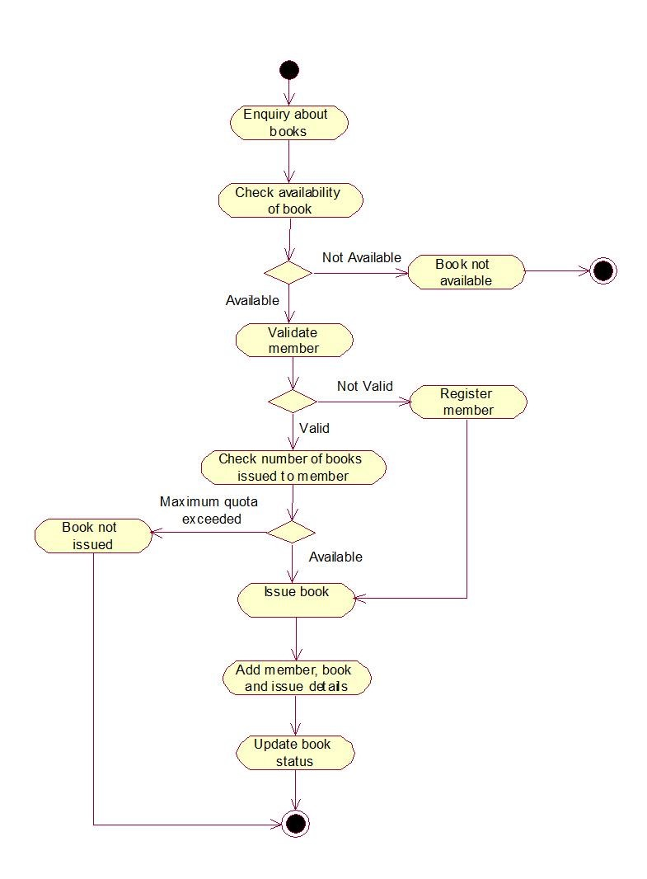

**Assignment No.6** : Sequence Diagram for Library Management System.

## ***LOGIN***

***REGISTER***

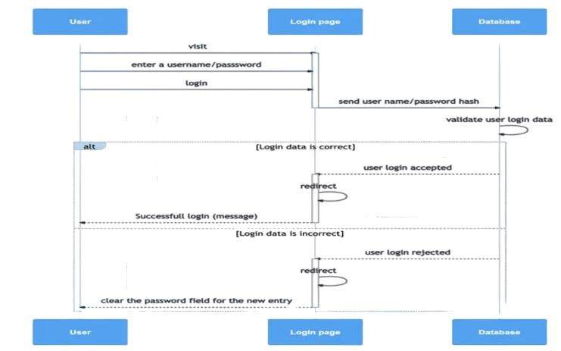

Click on register

Verify if data already

B

utton

exists

Data already present

Reserved apology

Update registration

Login successful

time

STUDENT

ADMIN

D

atabase

## ***SEARCH FOR A BOOK AND CHECK AVAILABILITY***

Enter book

details to search

Book details

if available

Else display not available

***ISSUE A BOOK***

STUDENT

DATABASE

Check availability

Request a book

Available

Check no. of issued books

Validate and issue a book

STUDENT

ADMIN

BOOKS

Database

**Assignment No.7** : Collaboration Diagram for Library Management System

***LOGIN***

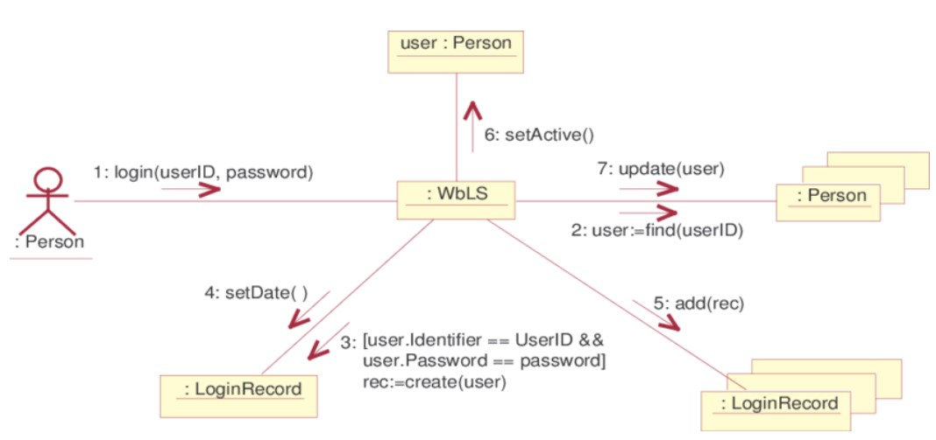

***REGISTER***

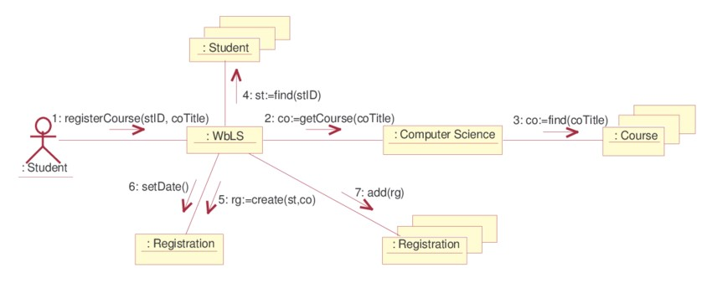

## ***ISSUE A BOOK***

